PASSWORD STRENGTH ANALYZER
Objective
The main objective of this project is to analyze the strength of a password and help users create secure passwords. This project checks whether the password is weak, medium, or strong based on different security conditions.
Software Requirements
- Python 3.x
- VS Code / IDLE
- Windows Operating System
Concepts Used
- Python Programming
- Regular Expressions
- Conditional Statements
- Functions
- User Input Handling
Algorithm
Step 1: Start the program.
Step 2: Get password input from the user.
Step 3: Check password length.
Step 4: Check whether the password contains:
- Uppercase letters
- Lowercase letters
- Numbers
- Special characters
Step 5: Calculate password strength.
Step 6: Display whether the password is Weak, Medium, or Strong.
Step 7: Stop the program.
Program Code
#python
import re
print("===== PASSWORD STRENGTH ANALYZER =====")
password = input("Enter your password: ")
score = 0
if len(password) >= 8:
score += 1
else:
print("❌ Password must contain at least 8 characters")
if re.search(r"[A-Z]", password):
score += 1
else:
print("❌ Add at least one uppercase letter")
if re.search(r"[a-z]", password):
score += 1
else:
print("❌ Add at least one lowercase letter")
if re.search(r"\d", password):
score += 1
else:
print("❌ Add at least one number")
if re.search(r"[@$!%*?&]", password):
score += 1
else:
print("❌ Add at least one special character")
print("\n===== RESULT =====")
if score == 5:
print("✅ Password Strength: STRONG")
elif score >= 3:
print("⚠ Password Strength: MEDIUM")
else:
print("❌ Password Strength: WEAK")
Sample Output
Example 1:
Enter your password: hello123
Weak Password
Example 2:
Enter your password: Hello@123
Strong Password
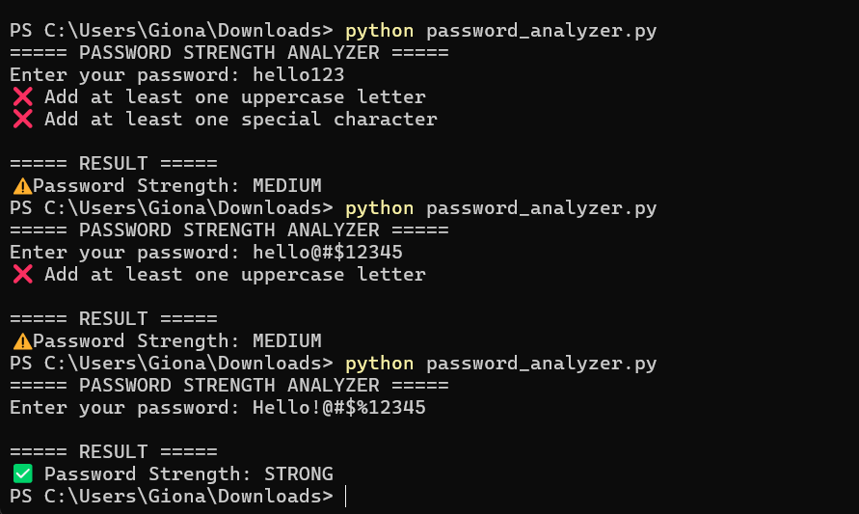

Conclusion
This project helps users create strong and secure passwords. It improves password security by checking different password conditions and providing strength analysis.

